Прочитайте текст и ответьте на вопросы к тексту.

Tower Bridge

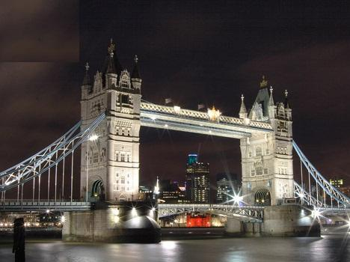

Tower Bridge is the most famous bridge over the River Thames. It is close to the Tower of London, which gives it its name. Sir John Wolfe Barry designed it.
The bridge consists of two towers which are tied together. The bridge was officially opened on 30 June 1894 by the Prince of Wales (the future King Edward VII), and his wife.
The bridge is 244 meters (800 feet) in length with two towers each 65 meters (213 feet) high.
Thousands of tourists visit Tower Bridge every year.
Questions: Ответы на вопросы записываем на английском языке, пользуясь текстом)
- What is the most famous bridge in London?
- Why does it give its name?
- When was Tower Bridge officially opened?
- Who was Tower Bridge officially opened by?
- Who designed Tower Bridge?

