Контрольная работа по теме
"Мои предстоящие каникулы".

- Для каждого из наборов слов 1 - 6 подберите обобщающее понятие из вариантов a - f.

1) a ship, a deck, on board | a) holiday in Africa
2) deserts, jungles, lions | b) activity holiday
3) a statue, a monument, a bus | c) holiday in the countryside
4) running, jumping, horse-riding | d) sightseeing tour
5) forests, cows, fields | e) beach holiday
6) a seashore, sand, to swim | f) a voyage

2. Прочитайте текст и определите истинность утверждений 1 - 5 после него. Выберите свой ответ из вариантов a и b.
Dear Lisa,
Hi from sunny Mexico! I am having a great holiday with my family. My little brother is in the water all day. I think he'll turn into a fish. Mum is relaxing and sunbathing on the beach now. Dad says he won't ever get tired of fishing. I am going swimming this afternoon. I think it will be very exciting. You won't believe how beautiful it is here. I'll show you all the photos when I come home. I hope you are having fun at home. Maybe next year you'll spend your holiday with us.
Love,
Kelly
a) true b) false

1) Kelly's brother likes swimming.
2) Kelly's mother is sunbathing today.
3) Kelly's father doesn't like fishing.
4) Kelly is going jumping
5) Kelly wants to show Lisa all the photos.

- В каждом из случаев 1 - 7 выберите из вариантов a - e грамматический способ выражения будущего времени и причину его употребления.

1) I think our train will arrive at 10 o'clock tomorrow.
2) I've bought a ticket and I'm going to the cinema next week.
3) I was going to visit my grandfather but it was too hot.
4) Next week I'll go to school every day.
5) I'm going to meet with my classmates.
6) I'm having a nice trip to Norway this summer.
7) I don't know when we will see an ocean.

a) Present Progressive: запланированные действия в будущем.
b) Future Simple: возможные действия в будущем.
c) Future Simple: повторяющиеся действия в будущем.
d) Конструкция "to be going to" в Present Simple: текущее намерение.
e) Конструкция "to be going to" в Past Simple: прошлое намерение.

- Соотнесите описания ситуаций 1 - 8 и ваши реплики в них a - h.

1) It’s a party on the 25th of December. | a) Good luck!
2) Your friend asks: “How are you?" | b) Have a nice trip!
3) Your friend wants to drink. | c) Get well soon.
4) You are at your friend's birthday party. | d) I'm fine, thanks.
5) Your friend is going to take an exam. | e) Happy New Year!
6) Your friend is going to visit London. | f) Shall I give you a cup of tea?
7) Your friend is ill. | g) Merry Christmas!
8) It’s a party on the 31st of December. | h) Happy birthday to you!

5. Кратко ответьте на вопросы по картинке.
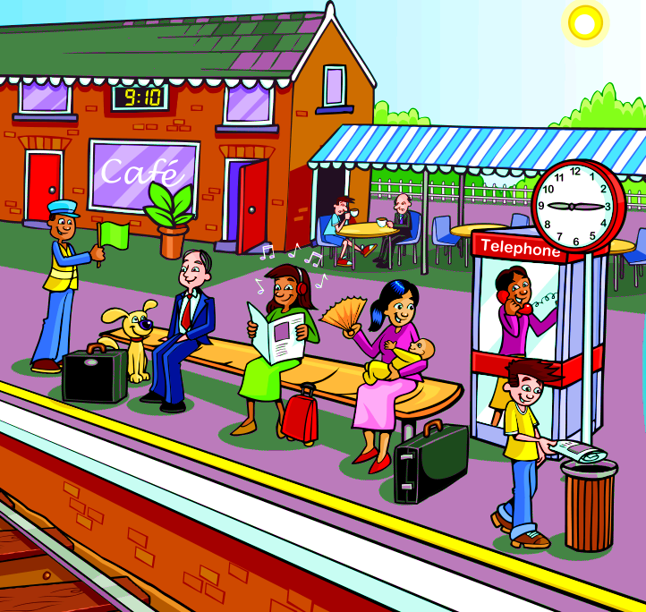

1) Is the time on the round clock is ten minutes past nine?
2) What has the men in the uniform got in his hand?
3) How many women are there on the picture?
4) What pet is sitting near the man?
5) Are these people going to travel?

